Explain ResultSet and ResultSetMetaData

ResultSet Interface
The result of the query after execution of database statement is returned as table of data according to rows and columns. This data is accessed using the ResultSet interface.
A default ResultSet object is not updatable and the cursor moves only in forward direction.
Creating ResultSet Interface
To execute a Statement or PreparedStatement, we create ResultSet object.
Example
Statement stmt = connection.createStatement();
ResultSet result = stmt.executeQuery("select * from Students");
Or
String sql = "select * from Students";
PreparedStatementstmt = con.prepareStatement(sql);
ResultSet result = stmt.executeQuery();
ResultSet Interface Methods

Methods Description
public boolean absolute(int row) Moves the cursor to the specified row in the ResultSet object.
public boolean first() Moves the cursor to first value of ResultSet object.
public boolean last( ) Moves the cursor to the last row of the ResultSet object.
public boolean previous ( ) Just moves the cursor to the previous row in the ResultSet object.
public boolean next( ) It moves the curser forward one row from its current position.

Types of ResultSet Interface
1. ResultSet.TYPE_FORWARD_ONLY
The ResultSet can only be navigating forward.
2. ResultSet.TYPE_SCROLL_INSENSITIVE
The ResultSet can be navigated both in forward and backward direction. It can also jump from current position to another position. The ResultSet is not sensitive to change made by others.
3. ResultSet.TYPE_SCROLL_SENSITIVE
The ResultSet can be navigated in both forward and backward direction. It can also jump from current position to another position. The ResultSet is sensitive to change made by others to the database.

ResultSetMetaData Interface
ResultSetMetaData is an interface which provides information about a result set that is returned by an executeQuery() method. The ResultSetMetaData extends the Wrapper interface.
This interface provides the metadata about the database. It includes the information about the names of the columns, number of columns etc.
ResultSetMetaData Interface Methods

Methods Description
public String getColumnClassName(int column)- It returns the name of the Java class whose instances are created.
public intgetColumnCount() - It returns the number of columns in the ResultSet object.
public String getColumnName(int column) - Returns the column name from the ResutlSet object.
public intgetColumnType(int column) - It retrieves the column’s which is designated in SQL.
public String getSchemaName(int column) - Return the table’s schema which designed with column.
public String getTableName(int column) Returns the designed SQL table’s name.

Develop a JDBC Program to retrieve data from database
import java.sql.*;
class ResultSetTest
{
public static void main(String args[])
{
Connection con = null;
Statement stmt = null;
ResultSetrs = null;
try
{
Class.forName("oracle.jdbc.driver.OracleDriver");
con = DriverManager.getConnection("jdbc:oracle:thin:@localhost:1521:XE", "scott", "tiger");
stmt = con.createStatement (ResultSet.TYPE_SCROLL_SENSITIVE, ResultSet.CONCUR_UPDATABLE);
rs = stmt.executeQuery("Select * from Student");
rs.absolute(5); //Accessing 5th row
System.out.println(rs.getInt(1)+" "+rs.getString(2)+" "+rs.getString(3));
rs.close();
stmt.close();
con.close();
}
catch(Exception e)
{
e.printStackTrace();
}
}
}

What is JDBC? Explain the role & responsibility of JDBC API. *
JDBC stands for Java Database Connectivity. JDBC is a Java API to connect and execute the query with the database. It is a specification from Sun Microsystems that provides a standard abstraction(API or Protocol) for Java applications to communicate with various databases. It provides the language with Java database connectivity standards. It is used to write programs required to access databases. JDBC, along with the database driver, can access databases and spreadsheets. The enterprise data stored in a relational database(RDB) can be accessed with the help of JDBC APIs.
JDBC API uses JDBC drivers to connect with the database. There are four types of JDBC drivers:
- JDBC-ODBC Bridge Driver,
- Native Driver,
- Network Protocol Driver, and
- Thin Driver
API stands for Application Programming Interface. It is essentially a set of rules and protocols which transfers data between different software applications and allow different software applications to communicate with each other. Through an API one application can request information or perform a function from another application without having direct access to it’s underlying code or the application data.

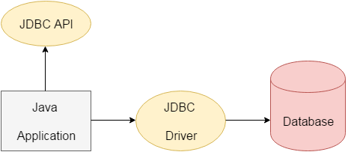
The current version of JDBC is 4.3. It is the stable release since 21st September, 2017. It is based on the X/Open SQL Call Level Interface. The java.sql package contains classes and interfaces for JDBC API.
A list of popular interfaces of JDBC API are given below:
- Driver interface
- Connection interface
- Statement interface
- PreparedStatement interface
- CallableStatement interface
- ResultSet interface
- ResultSetMetaData interface
- DatabaseMetaData interface
- RowSet interface
We can use JDBC API to handle database using Java program and can perform the following activities:
- Connect to the database
- Execute queries and update statements to the database
- Retrieve the result received from the database.
What is JDBC? Describe the steps need to execute a SQL query using JDBC
JDBC stands for Java Database Connectivity. JDBC is a Java API to connect and execute the query with the database. It is a specification from Sun Microsystems that provides a standard abstraction(API or Protocol) for Java applications to communicate with various databases. It provides the language with Java database connectivity standards. It is used to write programs required to access databases. JDBC, along with the database driver, can access databases and spreadsheets. The enterprise data stored in a relational database(RDB) can be accessed with the help of JDBC APIs.
There are 5 steps to connect any java application with the database using JDBC. These steps are as follows:
- Register the Driver class
- Create connection
- Create statement
- Execute queries
- Close connection

1) Register the driver class
The forName() method of Class class is used to register the driver class. This method is used to dynamically load the driver class.

Syntax of forName() method
public static void forName(String className)throws ClassNotFoundException
Class.forName("oracle.jdbc.driver.OracleDriver");

2) Create the connection object
The getConnection() method of DriverManager class is used to establish connection with the database.

Syntax of getConnection() method
1) public static Connection getConnection(String url)throws SQLException
2) public static Connection getConnection(String url,String name,String password)
throws SQLException

Connection con=DriverManager.getConnection("jdbc:oracle:thin:@localhost:1521:xe","system","password");

3) Create the Statement object
The createStatement() method of Connection interface is used to create statement. The object of statement is responsible to execute queries with the database.

Syntax of createStatement() method
public Statement createStatement()throws SQLException

Statement stmt=con.createStatement();

4) Execute the query
The executeQuery() method of Statement interface is used to execute queries to the database. This method returns the object of ResultSet that can be used to get all the records of a table.

Syntax of executeQuery() method
public ResultSet executeQuery(String sql)throws SQLException
ResultSet rs=stmt.executeQuery("select * from emp");
while(rs.next()){
System.out.println(rs.getInt(1)+" "+rs.getString(2));
}

5) Close the connection object
By closing connection object statement and ResultSet will be closed automatically. The close() method of Connection interface is used to close the connection.
public void close()throws SQLException

con.close();

import java.sql.*;
class ResultSetTest
{
public static void main(String args[])
{
Connection con = null;
Statement stmt = null;
ResultSetrs = null;
try
{
Class.forName("oracle.jdbc.driver.OracleDriver");
con = DriverManager.getConnection("jdbc:oracle:thin:@localhost:1521:XE", "scott", "tiger");
stmt = con.createStatement (ResultSet.TYPE_SCROLL_SENSITIVE, ResultSet.CONCUR_UPDATABLE);
rs = stmt.executeQuery("Select * from Student");
rs.absolute(5); //Accessing 5th row
System.out.println(rs.getInt(1)+" "+rs.getString(2)+" "+rs.getString(3));
rs.close();
stmt.close();
con.close();
}
catch(Exception e)
{
e.printStackTrace();
}
}
}

What is a JDBC driver? Explain each with a simple architecture

JDBC Drivers Types
JDBC driver implementations vary because of the wide variety of operating systems and hardware platforms in which Java operates. Sun has divided the implementation types into four categories, Types 1, 2, 3, and 4, which is explained below −

Type 1 − JDBC-ODBC Bridge Driver
In a Type 1 driver, a JDBC bridge is used to access ODBC drivers installed on each client machine. Using ODBC, requires configuring on your system a Data Source Name (DSN) that represents the target database.
When Java first came out, this was a useful driver because most databases only supported ODBC access but now this type of driver is recommended only for experimental use or when no other alternative is available.
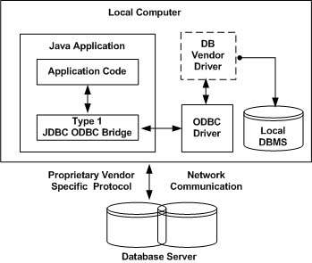
The JDBC-ODBC Bridge that comes with JDK 1.2 is a good example of this kind of driver.

Type 2 − JDBC-Native API
In a Type 2 driver, JDBC API calls are converted into native C/C++ API calls, which are unique to the database. These drivers are typically provided by the database vendors and used in the same manner as the JDBC-ODBC Bridge. The vendor-specific driver must be installed on each client machine.
If we change the Database, we have to change the native API, as it is specific to a database and they are mostly obsolete now, but you may realize some speed increase with a Type 2 driver, because it eliminates ODBC's overhead.
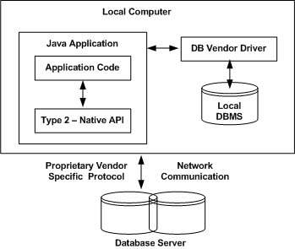
The Oracle Call Interface (OCI) driver is an example of a Type 2 driver.

Type 3 − JDBC-Net pure Java
In a Type 3 driver, a three-tier approach is used to access databases. The JDBC clients use standard network sockets to communicate with a middleware application server. The socket information is then translated by the middleware application server into the call format required by the DBMS, and forwarded to the database server.
This kind of driver is extremely flexible, since it requires no code installed on the client and a single driver can actually provide access to multiple databases.
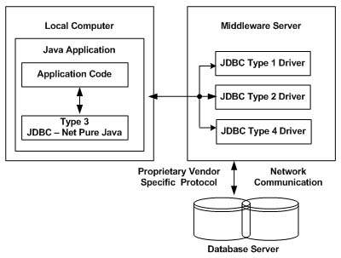
You can think of the application server as a JDBC "proxy," meaning that it makes calls for the client application. As a result, you need some knowledge of the application server's configuration in order to effectively use this driver type.
Your application server might use a Type 1, 2, or 4 driver to communicate with the database, understanding the nuances will prove helpful.

Type 4 − 100% Pure Java
In a Type 4 driver, a pure Java-based driver communicates directly with the vendor's database through socket connection. This is the highest performance driver available for the database and is usually provided by the vendor itself.
This kind of driver is extremely flexible, you don't need to install special software on the client or server. Further, these drivers can be downloaded dynamically.
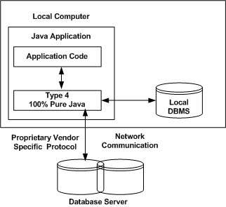
MySQL's Connector/J driver is a Type 4 driver. Because of the proprietary nature of their network protocols, database vendors usually supply type 4 drivers.

The PreparedStatement interface extends the Statement interface it represents a precompiled SQL statement which can be executed multiple times. This accepts parameterized SQL quires and you can pass 0 or more parameters to this query.
Initially this statement uses place holders “?” instead of parameters, later on you can pass arguments to these dynamically using the setXXX() methods of the PreparedStatement interface.

Creating a PreparedStatement
You can create an object of the PreparedStatement (interface) using the prepareStatement() method of the Connection interface. This method accepts a query (parameterized) and returns a PreparedStatement object.
When you invoke this method the Connection object sends the given query to the database to compile and save it. If the query got compiled successfully then only it returns the object.
To compile a query, database doesn’t require any values so you can use (zero or more) placeholders (Question marks ” ?”) in the place of values in the query.
For example, if you have a table named Employee in the database, created using the following query.
CREATE TABLE Employee(Name VARCHAR(255), Salary INT NOT NULL, Location VARCHAR(255));

Then the you should can use a Prepared Statement to insert values in to it as shown below.
//Creating a Prepared Statement
String query="INSERT INTO Employee(Name, Salary, Location)VALUES(?, ?, ?)";
Statement pstmt = con.prepareStatement(query);

Setting values to the place holders
The PreparedStatement interface provides several setter methods such as setInt(), setFloat(), setArray(), setDate(), setDouble() etc.. to set values to the place holders of the prepared statement.
These methods accept two arguments, one is an integer value representing the placement index of the place folder and, the other is an int or, String or, float etc… representing the value you need to insert at that particular position.
You can set values to the place holders of the above created statement using the setter methods as shown below:
pstmt.setString(1, "Amit");
pstmt.setInt(2, 3000);
pstmt.setString(3, "Hyderabad");

Executing the Prepared Statement
Once you have created the PreparedStatement object you can execute it using one of the execute() methods of the PreparedStatement interface namely, execute(), executeUpdate() and, executeQuery().
- execute(): This method executes normal static SQL statements in the current prepared statement object and returns a boolean value.
- executeQuery(): This method executes the current prepared statement and returns a ResultSet object.
- executeUpdate(): This method executes SQL DML statements such as insert update or delete in the current Prepared statement. It returns an integer value representing the number of rows affected.

import java.sql.*;
class ResultSetTest
{
public static void main(String args[])
{
Connection con = null;
Statement stmt = null;
ResultSetrs = null;
try
{
Class.forName("oracle.jdbc.driver.OracleDriver");
con = DriverManager.getConnection("jdbc:oracle:thin:@localhost:1521:XE", "scott", "tiger");

PreparedStatement psmt = con.prepareStatement(“update student set marks=? Where rollno=?”);

psmt.setInt(1,90);
psmt.setInt(2,101);
psmt.executeUpdate();
System.out.println(“Record Updated”);
}
}

What is JDBC? Develop a JDBC program to implement the following: *
JDBC stands for Java Database Connectivity. JDBC is a Java API to connect and execute the query with the database. It is a specification from Sun Microsystems that provides a standard abstraction(API or Protocol) for Java applications to communicate with various databases. It provides the language with Java database connectivity standards. It is used to write programs required to access databases. JDBC, along with the database driver, can access databases and spreadsheets. The enterprise data stored in a relational database(RDB) can be accessed with the help of JDBC APIs.

- Create a table
- Insert a record
- Delete a record.

//create a table
import java.sql.*;
class JDBC {
public static void main(String args[])
{
Connection con = null;
Statement stmt = null;
ResultSetrs = null;
try
{
Class.forName("oracle.jdbc.driver.OracleDriver");
con = DriverManager.getConnection("jdbc:oracle:thin:@localhost:1521:XE", "scott", "tiger");

PreparedStatement psmt = con.prepareStatement(“create table student(rollno number,name varchar2(50),total number)”);
System.out.println(“Student Table Created”);
}
}

//Insert a Record

import java.sql.*;
class JDBC
{
public static void main(String args[])
{
Connection con = null;
Statement stmt = null;
ResultSetrs = null;
try
{
Class.forName("oracle.jdbc.driver.OracleDriver");
con = DriverManager.getConnection("jdbc:oracle:thin:@localhost:1521:XE", "scott", "tiger");

PreparedStatement psmt = con.prepareStatement(“insert into student values(101,’K Ravi’,500)”);
System.out.println(“Row Inserted”);
}
}

//Delete a Record

import java.sql.*;
class JDBC
{
public static void main(String args[])
{
Connection con = null;
Statement stmt = null;
ResultSetrs = null;
try
{
Class.forName("oracle.jdbc.driver.OracleDriver");
con = DriverManager.getConnection("jdbc:oracle:thin:@localhost:1521:XE", "scott", "tiger");

PreparedStatement psmt = con.prepareStatement(“delete from student where rollno=101”);
System.out.println(“Record Deleted”);
}
}

